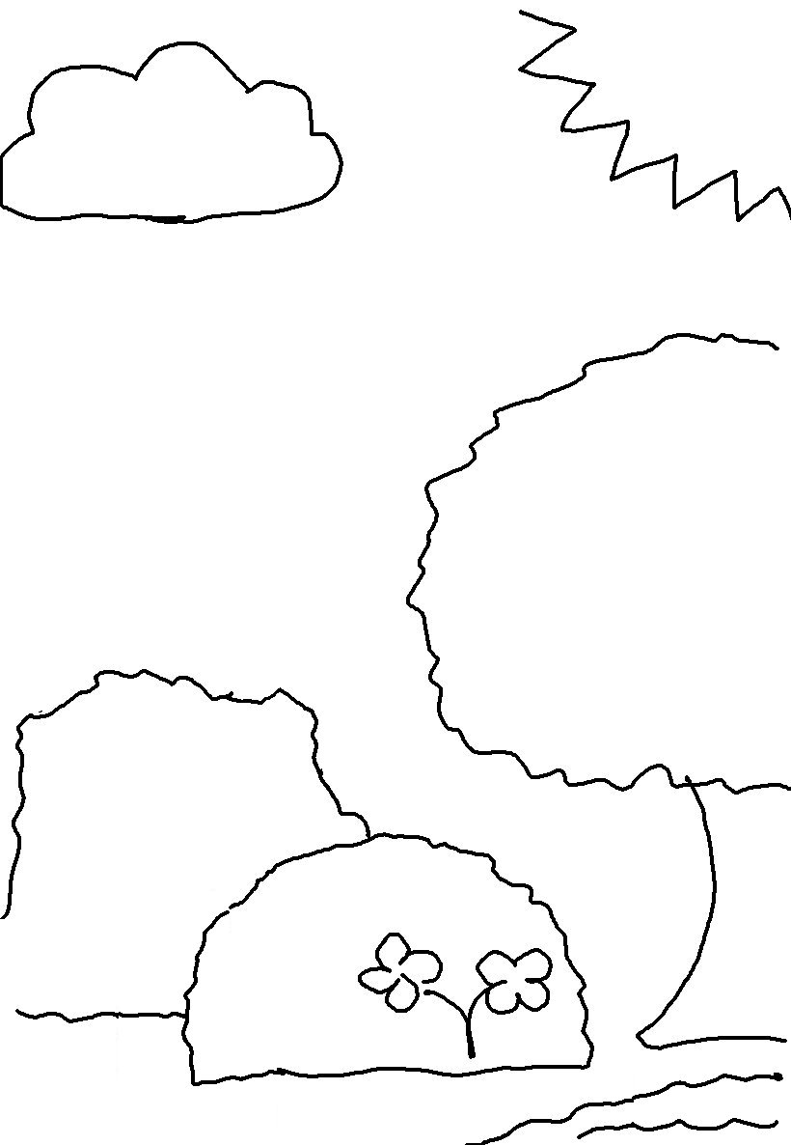
In the beginning _ _ _ created the heavens and the _ _ _ _ _.
Genesis 1:1

